Your Name: Matthew Bespalko
Course: ELTR-138 Digital Integrated Circuits 2
Program: Computer Automated System Technician
Campus: Regina Wascana
Learning Outcome: Learning Outcome - Explain the basic operation of a microprocessor system.
Learning Steps: Describe the blocks in a microprocessor system. Describe the process of how the block work together.

Introduction
In an effort to demystify the operations of a microprocessor system for my students, I chose an active learning strategy that involved role-playing the various components of the 8085 microprocessors. This hands-on approach was designed to deepen students' understanding of microprocessor architecture and functionality while understanding how to interpret the machine code instruction language.

Choice of Formative Assessment Strategy
The selected formative assessment strategy was a role-play activity, where each student was assigned to represent different components of the 8085 microprocessors, such as the Arithmetic Logic Unit (ALU), Accumulator, Registers, and the Data Bus. This strategy was chosen to facilitate a practical understanding of how individual microprocessor components interact to process instructions.
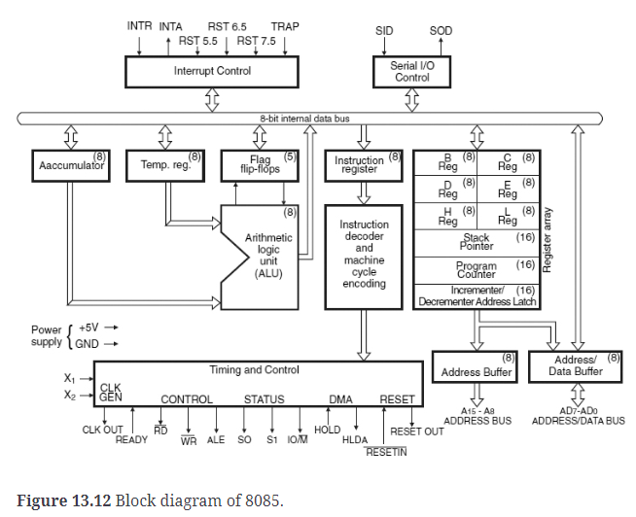
Figure 1: 8085 Block Diagram

Implementation
This strategy was implemented during a single class session dedicated to exploring the architecture of the 8085 microprocessors. The lesson began with a brief PowerPoint personation defining the parts of the 8085 microprocessors. Students were then given name tags corresponding to their assigned microprocessor component and were tasked with acting out the processing of a set of machine instructions. The activity involved a step-by-step walkthrough of instruction execution, from data movement to arithmetic operations and outputting results to LEDs, represented by port 11 in the instruction set provided.
Address | Data | Instruction | Comments
FF01 | 06 | MIV B, D8 | Move immediate an 8-bit value to register B.
FF02 | 2A |  | The 8-bit value is 2A
FF03 | 0E | MVI C, D8 | Move immediate an 8-bit value to register C.
FF04 | B9 |  | The 8-bit value is B9
FF05 | 81 | ADD, C | The content of register C is added to the content of the accumulator. The result is placed in the accumulator.
FF06 | 80 | ADD, B | The content of register B is added to the content of the accumulator. The result is placed in the accumulator.
FF07 | D3 | OUT D8 | Output the 8-bit value in Reg A to a port
FF08 | 11 |  | Port 11 is the LEDs
FF09 | C3 | JMP FF07 | Jump to FF07 and repeat
FF0A | 07
FF0B | FF

Table 1: Example of Machine Code Instructions Students Received.
To role-play the execution of the provided machine code instructions using the 8085 microprocessor components, students assigned to each part will need to understand and simulate the specific actions their component performs. Here's a breakdown of what each student representing a component of the 8085 affected by these instructions would need to do:
Preparing the Stage
First, I rearranged the classroom to resemble the internal architecture of the 8085 microprocessor seen in figure 1. I designated specific areas for the key components: the Accumulator, ALU, Registers B and C, the Data Bus, the Control Unit, and the Output Port (Port 11). Each area was marked to represent its corresponding part in the microprocessor, setting the stage for the students to visualize and physically enact the data flow and processing steps.

I also prepared materials to represent the "bits" — pieces of paper with the 8-bit values (`2A` and `B9`) written on them. These were to be carried by students as they moved around the classroom, simulating the movement of data within the microprocessor.
Conducting the Role-play
Register B and C - Storing Values
I assigned students to play the roles of Register B and C. The student representing Register B was tasked with fetching the `2A` bit representation from the "Data Bus" area, embodying the MVI instruction's execution. After collecting it, they returned to their "Register B" space to "store" the value. The process was mirrored by the student playing Register C with the `B9` value.
Accumulator - Adding and Storing Results
For the ADD instructions, I directed the student acting as the Accumulator to interact with the ALU student for each addition operation. They walked to the ALU, carrying the current value of the Accumulator, where they "added" the values from Registers B and C in sequence. Each time, the ALU student simulated the addition, and the Accumulator student returned to their area with the new sum, representing the updated value in the Accumulator.
Output Port - Displaying the Result
After completing the additions, the student representing the Accumulator proceeded to the Output Port (Port 11) area to "output" the final Accumulator value, handing it to the student playing the Output Port. This action symbolized the microprocessor's process of sending the result to the LEDs connected to port 11.
Jump Instruction - Looping the Process
As the Control Unit, I announced the execution of the jump instruction back to address FF07, signaling the Accumulator student to repeat the output action to Port 11. We went through this loop several times to emphasize the concept of cyclical instruction processing.
Enhancing the Learning Experience
Throughout the activity, I encouraged students to verbally announce their actions, fostering a lively and engaging learning atmosphere. For instance, the ALU student would say, "Adding B9 to the Accumulator's current value of 2A, resulting in the new sum."
After a few cycles, I paused the role-play for a moment of reflection, asking students to share their insights about their component's role in the microprocessor's functionality. This discussion helped solidify their understanding and appreciation of the complex interactions within a microprocessor system.
This hands-on, dynamic approach not only made the abstract concepts of microprocessor operations tangible for my students but also significantly enriched their learning experience, making it a memorable lesson in understanding the inner workings of a microprocessor.

Learner Reactions
Learner reactions to this formative assessment strategy were overwhelmingly positive. Students were engaged and showed keen interest in the hands-on aspect of learning. The role-play enabled them to visualize the dynamic operations within a microprocessor, making the theoretical aspects more tangible.
Observations on Learner Understanding
The role-play activity revealed significant insights into the students' levels of understanding. It became evident that students were able to grasp the concepts of data movement and the execution of instructions within a microprocessor more effectively. Their ability to explain the operations as we progressed indicated a deepening comprehension of the microprocessor system's basic operations.
Outcomes
What Went Well:
The engagement and active participation of students were high.
The role-play facilitated a clearer understanding of the microprocessor's operational flow.
Students were able to articulate the function of each component and their role in processing instructions.
Challenges:
Ensuring that all students had an equal opportunity to participate actively posed a slight challenge.
Some students required additional guidance to understand their component's role in the broader system.
Reflections for Future Practice
For future iterations of this lesson, I would consider incorporating more complex instructions to challenge advanced learners further and possibly integrate technology to simulate the microprocessor's operations visually.
Main Learning and Professional Impact
This experience reaffirmed the value of active learning strategies in technical education, particularly in demystifying complex systems like microprocessors. Professionally, it has encouraged me to explore and integrate more interactive and participatory methods into my teaching practice, significantly impacting how I approach lesson planning and execution in the future.
Relevance:
The activity was highly relevant to the learning outcome, directly engaging students in the practical application of theoretical knowledge. (Score: 4/4)
Critical Thinking:
Students demonstrated a depth of analysis by actively applying and discussing the roles and interactions of microprocessor components. (Score: 4/4)
Context:
The activity was well-linked to the specific course and learning outcome, providing a contextual framework for understanding microprocessor operations. (Score: 4/4)
Readability:
The preparation and execution of this formative assessment strategy were conducted with clarity and attention to detail, ensuring high readability and understanding. (Score: 4/4)

